Processing Year End
Tax Forms

Microsoft Dynamics NAV

Versions
2013 R2 / 2016
Vertex Systems, Inc.
2550 Corporate Exchange Dr. #104, Columbus, OH 43231

Email: support@vertexsystems.com
Website: https://www.vertexsystems.com

Important: This document has been prepared by Vertex Systems as a guideline and handbook for Year End tax processing. Vertex customers using NaviPayroll are expected to follow the guidelines in this document and ensure conformity. There are several tasks that require to be done ahead of time and failure to carry out them in a timely manner may result in processing delays. If the pre-checks have not been carried out ahead of time and issues are generated while processing tax filings Vertex Systems may or may not be able to resolve them amidst tight deadlines, support tickets would be handled on a first come first serve basis. Furthermore if data entry errors are identified such would have to be recertified by the customer and would require time.
Contents
1. Ordering the Tax Forms 2
2. Mandatory pre-checks to be performed 3
2.1 Updating Greenshades 3
2.2 Check the registration key 3
2.3 Review your computer and server time setting 3
2.4 Review Deadlines 3
2.5 Register with the SSA 3
2.6 Review Company Information 4
2.7 Review the Payroll Setup 4
3. Pre-checks on Employer, Employee and Payroll data 5
3.1 Employer card 5
3.2 Reporting Authorities 5
3.3 Tax form class codes 5
3.4 Employee records. 5
3.5 Review and reconcile Payroll data. 6
4. Working with the Greenshades Filing Center 7
5. Working with the Greenshades Forms Center 13
5.1 Setting Employee Access 15
5.2 Processing the Forms 17

Ordering the Tax Forms
Customers using Microsoft Dynamics NAV 2013R2 and Microsoft Dynamics NAV 2016 have the option to generate W-2 or W-2, 4-up from NAV or process W-2's via Greenshades. Make certain you purchase the correct forms depending on how you process the W-2's. If printing from NAV, you will want to purchase the pre-printed forms. If processing the W-2's from Greenshades, you will want to purchase blank forms.
You may source these forms through an external supplier or through Vertex Systems. If sourced through Vertex we offer deep discounts whilst ensuring software compatibility for customers covered under our Maintenance and Support agreement.
EFW2 for SSA: Please remember that even if the W-2's are printed from NAV, the electronic file for the SSA (EFW2) must be generated from Greenshades. The fee charged by Greenshades is currently published at $0.35 per W-2. However, Greenshades has not finalized the fee for the current tax season and may revise it towards the end of the tax season (December).
If orders for the forms have not yet been placed please do so to ensure availability. Vertex sends out the communication to order forms in September of each year. If you have not received this communication please contact forms@vertexsystems.com.
If you have any questions regarding Greenshades, you may contact Vertex Systems NAV customer support at 800.536.3427 or email us at support@vertexsystems.com.

Mandatory pre-checks to be performed
The below listed mandatory pre-checks need to be performed well ahead of time. These should be done at least one month ahead of processing to avoid any unexpected issues that would likely result in processing delays.

Updating Greenshades
Open the Greenshades Filing Center early, long before you are ready to upload your data.
The Filing Center will almost certainly need to update, so this allows you to complete the majority of updates long before you are into your stressful season. Updates will be pushed out to the Filing Center throughout the regulatory season, so you will probably have additional updates to apply. However, this will get 11 months of updates out of the way.

Check the registration key
You can confirm that your Registration Key is active. If you receive an error message regarding your Registration Key, contact Vertex Support Team immediately. If you are a new customer, you can register and be assigned a key from the software; you do not need to contact the Vertex Support Team. To view your Registration Key, open Payroll > Setup > Greenshades Setup.

Review your computer and server time setting
You will use Greenshades for most of your regulatory submissions. Because there are strict deadlines around these submissions, the time setting on the computer doing the submission and the NAV server must be accurate. If the computer receives the time setting from the server, ensure that the server has the correct time. A discrepancy of even 5 minutes will result in an error message.

Review Deadlines
Please visit the below official government websites and obtain your tax filing deadlines.
- https://www.ssa.gov
- https://www.irs.gov

Register with the SSA
You must register to use the SSA's Business Services Online (BSO) to file electronically. Your BSO User ID does not expire; however, the password expires every 90 days. Make sure that your credentials are active. If you need to setup a new account you can call the SSA (800-772-6270) or apply online www.ssa.gov/bso/bsowelcome.htm

Review Company Information
Confirm the name and address information on the Company Information page.

Review the Payroll Setup
Review the Payroll Setup > Regulatory Reporting FastTab.
- Indicate where Payroll will save the year-end data file.
- Indicate where the Greenshades executable file is stored.
- Indicate if Greenshades will use the Company Email or the Email field on the Employee record. The email address is used for communication and can be used for logging into the Greenshades Center.

Pre-checks on Employer, Employee and Payroll data
Pre-checks on Employer, Employee and Payroll data should also be carried ahead of time. Do not wait till the last moment. If corrections are required they may require time and may impact deadlines if not addressed ahead of time.

Employer card
- If you have multiple companies in the database, each Employer No. and Employer Name must be unique across the companies.
- Review the W-2 and ACA contact fields on the Employer card and correct if necessary.
- Review the reporting authorities assigned to the employer - confirm the Identification No. for all applicable authorities and ensure that you have only the applicable reporting authorities assigned to the employer.
- Having unused reporting authority codes can impact performance and results.

Reporting Authorities
Review your reporting authorities and confirm that they are defined correctly.

Tax form class codes
Review your tax form class codes and ensure that all necessary boxes are defined correctly.

Employee records.
- Suffixes, like Sr., Jr. or III, should not be in the last name field. There is a separate Suffix field for this information. Tip: Use the Last Name field on the Employee list and you can check for this quickly and easily.
- Ensure that the mailing address is complete and up-to-date. Tip: Run the Employee Listing report (checking to include the Home Address). You can also include the SSN/SIN on this report.
- Ensure that you have a current email address (and in the correct field). For terminated employees, ensure that the email address is their personal email address (shouldn’t still be their work email address). Tip: If you are using the Email field (not the Company Email field on the Payroll Setup), you can show this field on the Employee list and review quickly and easily.
- Confirm that all applicable employees have the necessary ACA offer/coverage information. Reminder: You can update all or some employees from the Employer card > ACA page > Update Employee Offers task.
- Verify Social Security Numbers (SSNs) or Social Insurance Numbers. You can run the Social Security Review report to identify numbers that have not yet been validated, then validate SSNs from within Payroll or from the Greenshades Center. We recommend that you use the Social Security Verification tool, as the process to upload to Greenshades will skip employees when the SSN field is empty, or the SSN value is not 9 digits long. Tip: You can enter the SSN with formatting (123-45-6789) or without (123456789). You can identify SSNs without formatting with the Social Security Review report, but you do not need to correct that.

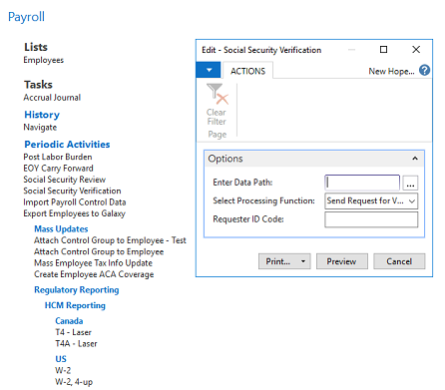

Review and reconcile Payroll data.
- Resolve any outstanding Payroll checks, voiding if necessary.
- Review the values that will be reported.
- Also, verify the FIT and Social Security basis amounts.
- You can use the Payroll Control Schedule feature to review your information.
- You can review ledger entries for Reporting Authorities and the Tax Form Class Code, if that helps you in your research.
- Correct any issues found. You can correct information in the Greenshades Center, but that information does not get sent back to Payroll. It is far better to correct Payroll first.

Working with the Greenshades Filing Center
The processing of W-2 and 1095-C Year End Forms are initiated through the Greenshades Filing Center. For this you should have Greenshades loaded onto your system under Payroll Administration Set up, see below. If for some reason you do not see the Greenshades set up, please contact Vertex Support Team so we can assist you.
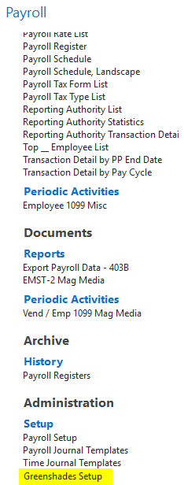
The next step will be to generate the W-2.

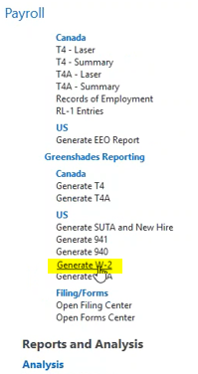
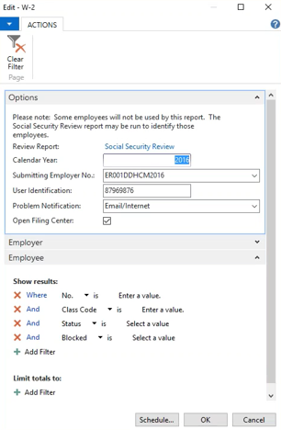
The above screen begins the creation of the E-File, include Calendar Year and the Submitting Employer No. from the drop down. The User Identification is the ID given by the IRS, this will be unique to your company. Problem Notification should be email/internet. Place a check mark on Open Filing Center and then click OK.
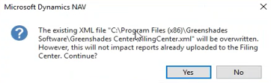
This warning will pop up and this means you have a file in the system already and it will overwrite. This should be ok, if you have saved previous file to a different location.
The data will be dumped into the FilingCenter.xml. Be very careful with this file there will be sensitive information in it. Below is an example of the data. This document needs to be protected and away from access by employees.
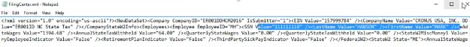
Subsequently the Greenshades Filing Center will open as below.
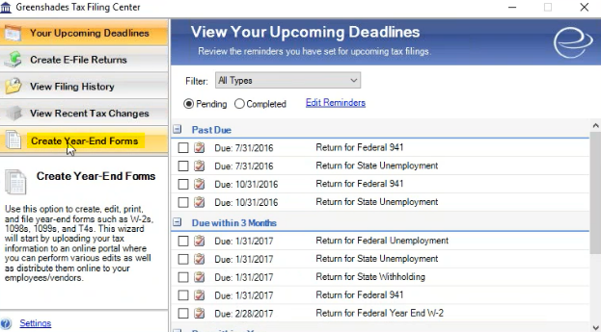

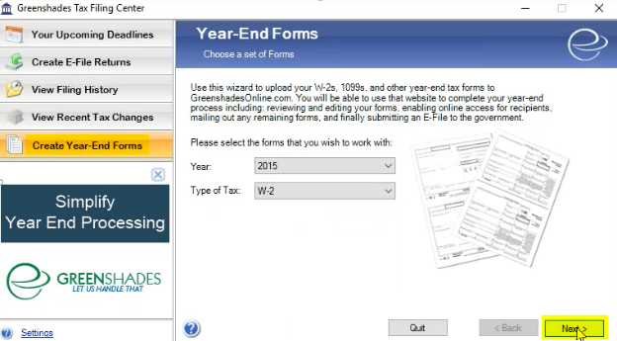

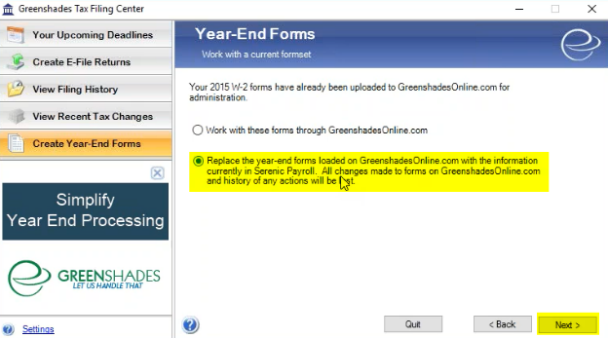
Follow the above screens, drop down options available if needed.
You can replace as many times as you want without double/triple billing. Basically everything seen here is included in Sceneric HCM except for a fee Greenshades charges to convert file into pdf. You can rerun this as many times as you like. A bill will not generate until there has been over a week of inactivity. After a week they will think you are done and a bill will generate.
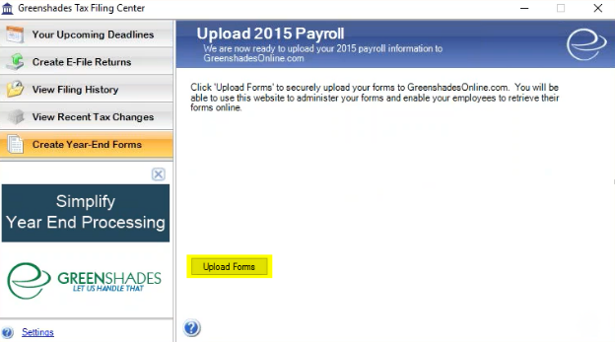

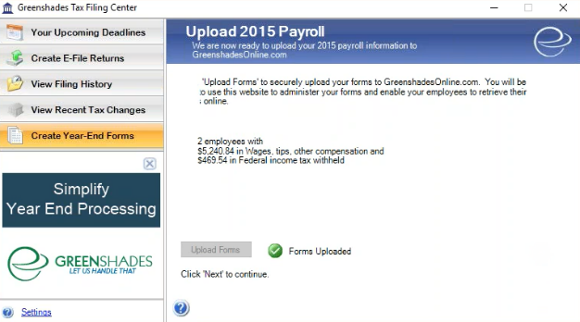
Follow the screens as above. Upload forms. Now the forms are done and are uploaded to Greenshades, it would be converted to pdf and loaded into portal.

The next step below is to pick who you want to have access to the portal. You can also add a new contact from the blue link in the top text.
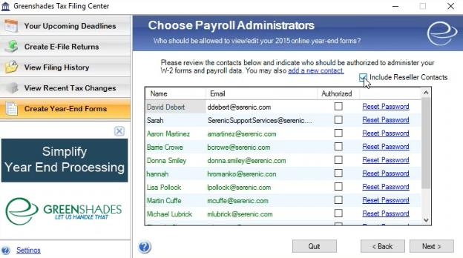
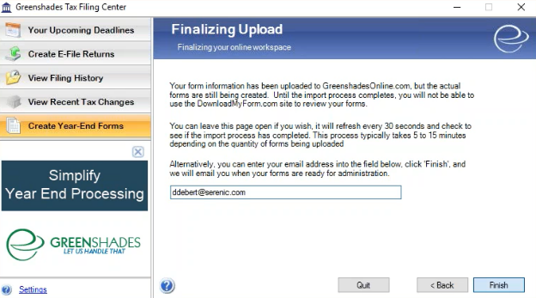
You can add a contact email on this page, the email will be notified when the forms are ready for review in the FORMS CENTER. There could be a lead time based on the number of W-2s being created. The handoff to Greenshades is complete and nothing else to be done inside Sceneric HCM at this point in time. Greenshades will process the W-2 and inform when the forms are ready for review.

Working with the Greenshades Forms Center
Greenshades will process the W-2 and inform when the forms are ready for review. After you receive the notification open the Greenshades Forms Center.
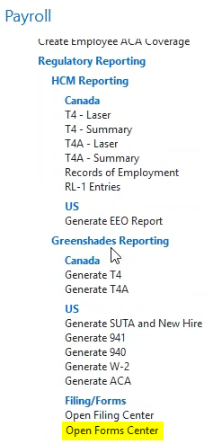

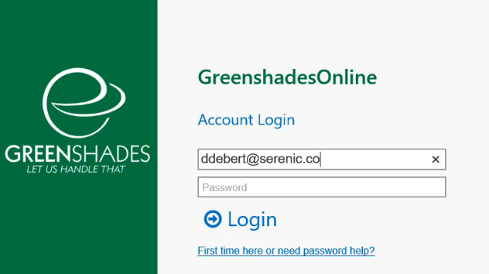
Enter the credentials and login. If you don’t have an account you may create one.
This will take you to your company dashboard. You are no longer in Sceneric HCM, all data has now been transferred to Greenshades to complete the final steps of creation and filing. If any issues arise, please contact the Vertex Support Team for support.
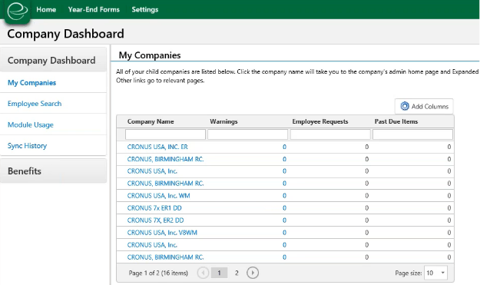

Setting Employee Access
Skip this section if you are using Company Email as the Employee Email Source in Payroll Setup Regulatory Reporting Fast Tab. Proceed to section 5.2
You may use the settings area to create company logo. Employees are going to see this when they log into the portal, so adding your logo is recommended to let them know they are in the right spot.
Click on SettingsAccess Settings to access Admin Settings if you want to define how the employee logs on this page. The admin is your control and contact area. Follow along the prompts and answer the questions to complete Access setup in Greenshades. Set up all steps to ensure access is as you want for employees.
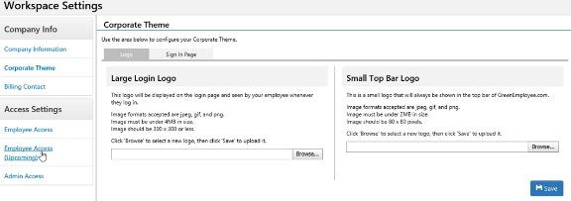
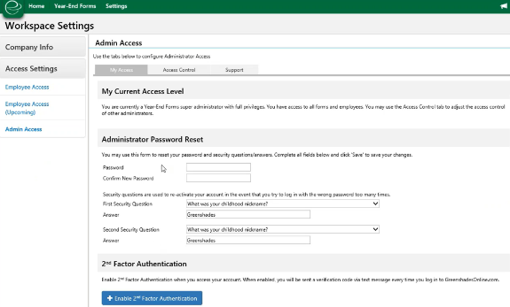
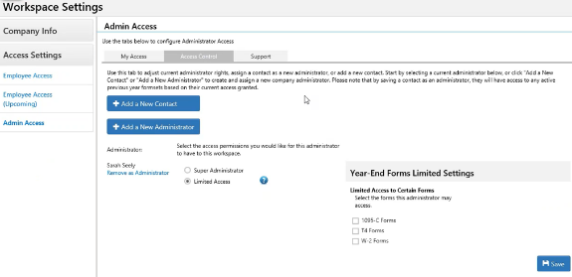

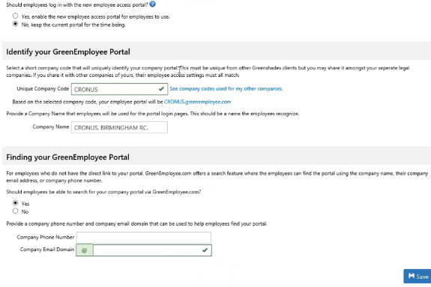
Please address all the above screens to ensure proper set up of form access and distribution. Pay attention to all tab across the middle of the screen My Access, Access Control and Support.

Processing the Forms
Specify in the ribbon bar to pull in the form you wish to review. Year, form type, etc.
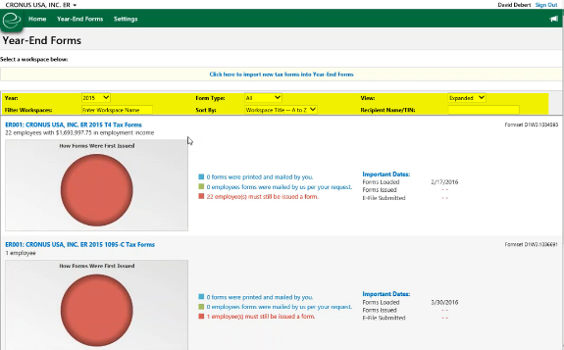

The below screen outlines what your forms are and how many. Also, an E-File due date is given.
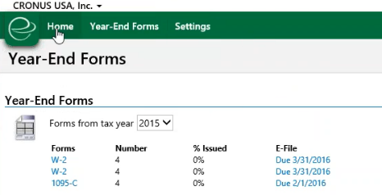

The employer number will relate to your company information. Making it easier to review.
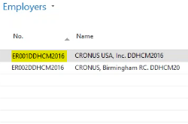
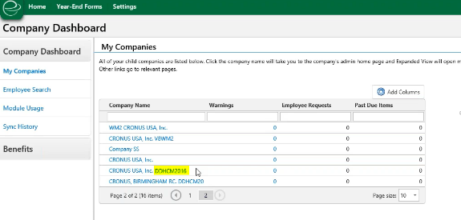
Select the correct company you want to review.
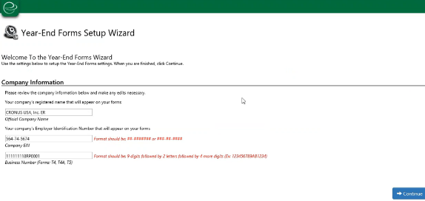
The subsequent steps manages the forms.
Please review each step to complete the process, a check will appear when the section is complete. If you have errors or warnings, please remember to also make the fix in NAV Serenic HCM to ensure data integrity. If you need to make a calculation fix in NAV Serenic HCM you can do that and download again to Greenshades. You need to have all corrected information in NAV Serenic HCM.
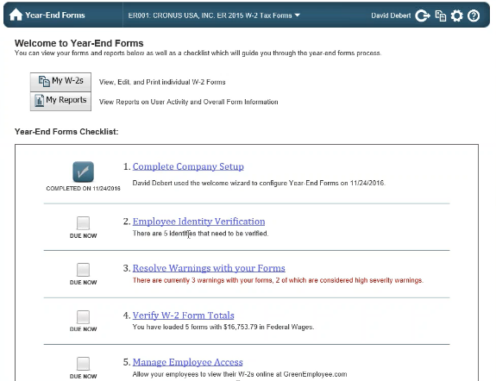
Employee Identify Verification can be corrected at this level, but again make sure to fix this is in NAV Serenic HCM as well.
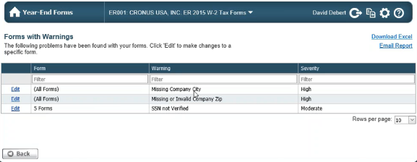

You can edit or print the W-2 from here. However if you edit you need to make the same changes in NAV Serenic HCM to ensure accuracy at all time.
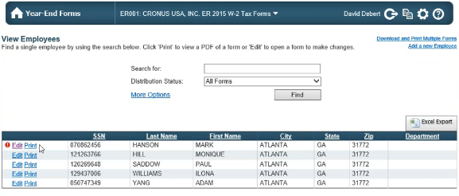
When you edit you will get the below screen.
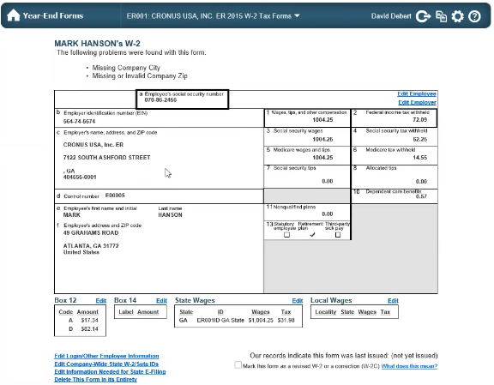
The blue lines give several options here to edit information, employee, employer, taxes or even delete the form in its entirety.
The next step allows download and printing options.
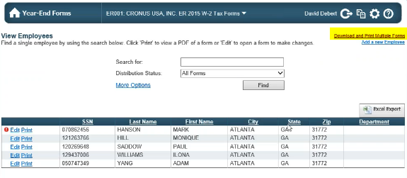
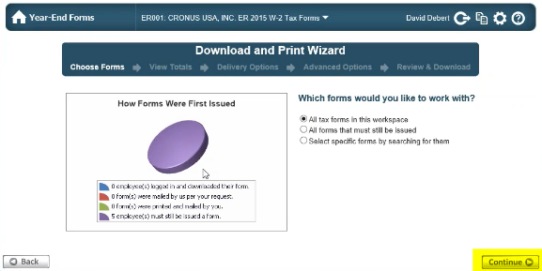
Support @ Greenshades download my batch will be the email received for the forms.

Directs you back to forms still missing information.
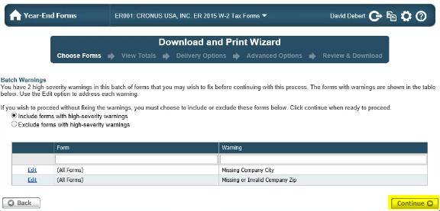
Subsequently the totals will be shown.
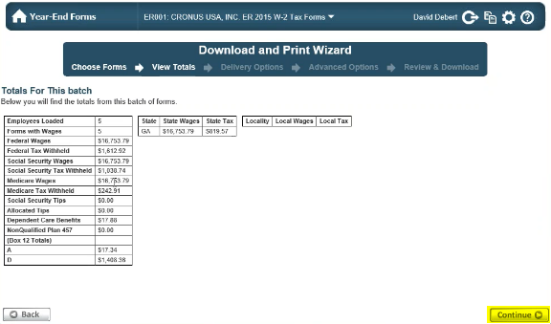

Next select the Forms options for forms and envelopes. If needed Greenshades could also print for you and mail it an additional fee.
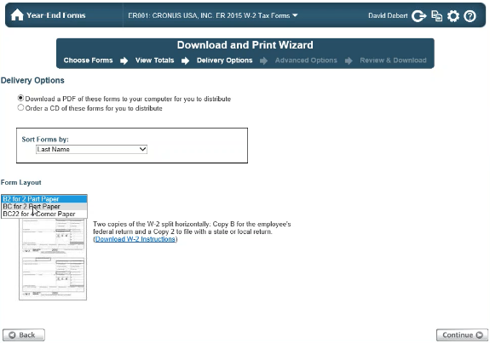

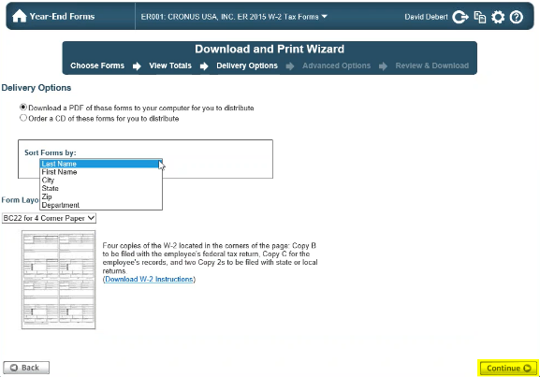
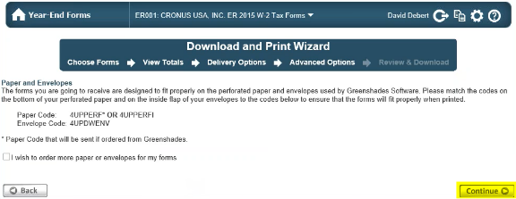
Make sure to place a check mark in the below highlighted if the forms are distributed by you and not Greenshades.
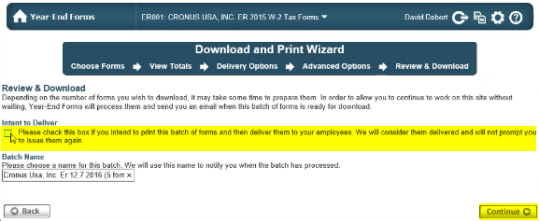
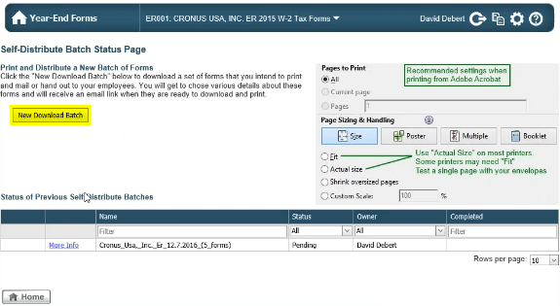
Same look and feel for 1095C, just select 1095C and the form will populate for your review exactly like the W-2’s. The below screens identify how the 1095C forms are created.
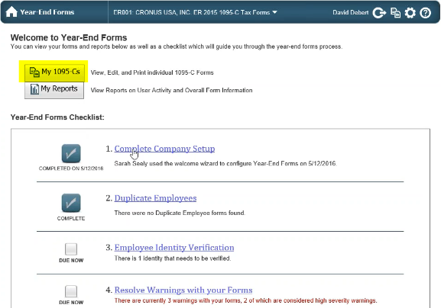
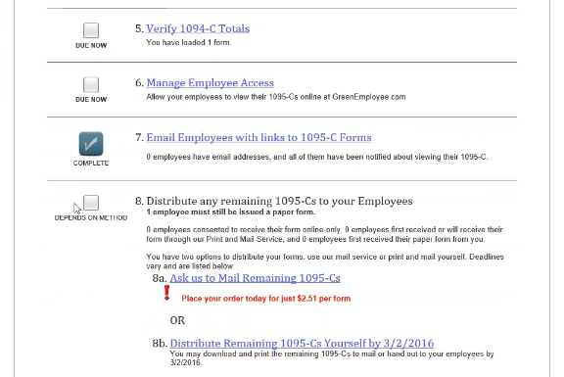
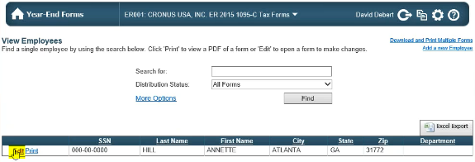
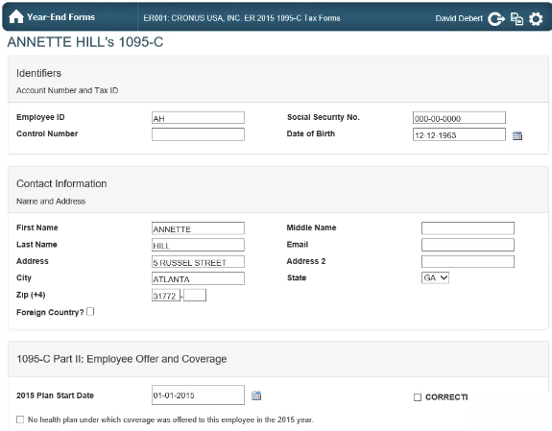
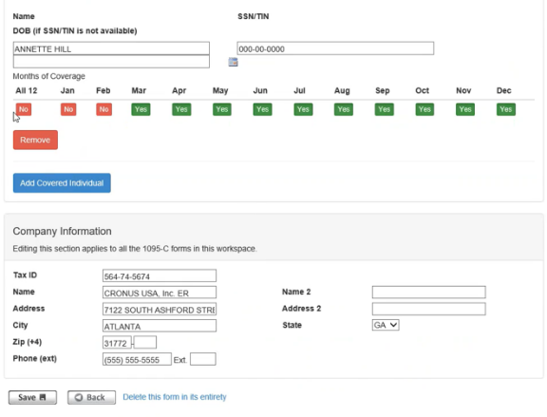

For further information contact Vertex Support at (800) 536-3427 or support@vertexsystems.com.

